Parties, Politics, and Political Participation NAME:
Mr. Faulhaber
“When Language Divides Us” Article Review PER:

When Language Divides Us: Words are rapidly being re-defined in a way that pits Americans against each other

Monica Harris
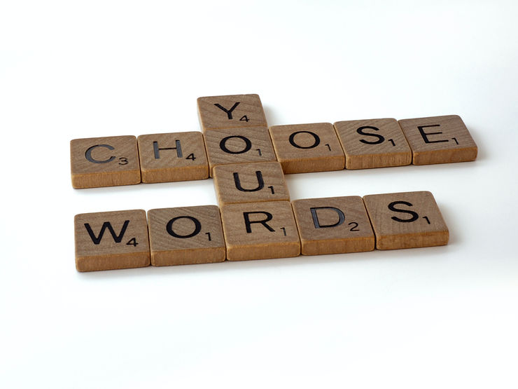
If you follow me, you know that I believe our debt-based Ponzi scheme economy is the root cause of all our systemic failures — from the housing and homeless crisis, to food insecurity, unaffordable healthcare, and environmental collapse. Yet we never discuss the Ponzi scheme that’s pulling America into crisis. This isn’t by chance; it happens because we’re divided.

When people are constantly pitted against each other, their greater human connection escapes them. They can’t appreciate what they have in common. It becomes much harder for them to see the source of their shared problems and to come together to solve them.

So why is America so divided now?

It’s no secret that cable news and social media have viciously polarized our country, trapping us in partisan echo chambers that reinforce our worldviews. Two halves of the country are constantly sparring with each other over which facts are “real” and which side is distorting them. You’ve probably had conversations with friends or family and walked away shaking your head and thinking, “They have no idea what I’m talking about. It’s like we’re living in completely different worlds.”

And you are. Because when you control the facts that people do (or don’t believe), you can literally shape their reality. When people in any society are living in different realities, chaos ensues.

Now a similar phenomenon is unfolding with our language, the words we use to create a shared understanding of our world. The foundation of this shared understanding is being re-defined in real time. It’s been going on for a while, but now it’s happening faster. Why does this matter? Because if you keep changing the linguistic glue that holds a civilized society together, you put larger groups of people on completely different pages. You force them into different realities. They have trouble communicating and understanding each other. And when people stop communicating, society buckles. Eventually, it falls into crisis. I believe this is what’s happening in America now.
My first experience with the re-defining of words was in law school. I grew up in the 70s and 80s believing that racism was discrimination based on race (just as sexism was discrimination based on sex, and ageism was discrimination based on age). Granted, this wasn’t a definition I’d bothered to look up in the dictionary, but every black person I knew had always moved through the world with the same interpretation. Our understanding of racism wasn’t controversial; it was just common sense. It wasn’t until I got to Harvard that I realized others might not be on the same page with me.

It happened in a class called “Race, Racism, and the Law.” Our professor (who was black) asked us to consider whether racism might require more than mere prejudice; that racism might actually be limited to discrimination practiced by people with power. Since white people were traditionally those in power, this meant that they, alone, could be racist. So if white partners at a law firm refused to hire a black lawyer based on the color of her skin, their actions were racist, but if a group of young black boys attacked a white woman outside a grocery store for the same reasons, their actions were race-neutral. Because if you weren’t white, you couldn’t possibly be racist.
Of course, language is dynamic and always evolving, but looking back I can see that my experience at Harvard wasn’t just significant in the context of the current Anti-racism movement; it represented the leading edge of an accelerating wave of changes in the language we use to describe our collective reality.
Take terrorism, for example. If you asked an American in October 2001 to describe a “terrorist,” they would almost certainly have limited their definition to foreign threats, especially of the Al Qaeda or ISIS variety. Fast forward 20 years, and our definition of “terrorist” has changed dramatically.
Now we’re being conditioned to think of “terrorists” not as foreign agents, but as average Americans — people we work with, live next door to us, and maybe even members of our family. They don’t need to be plotting to blow up a bridge or a building; having an “extreme” perspective is sufficient, and these days that doesn’t take much. Sharing disinformation, misinformation, and “dangerous conspiracy theories” can put you on the terror watch list. Questioning pandemic response policies, or merely “undermin[ing] public trust in government institutions” will also do the trick (the irony, of course, being that the freedom to question and even challenge government institutions lies at the heart of the Bill of Rights).
So great is the danger of domestic terrorism that the White House now considers it to be “the most urgent terrorism threat the United States faces.” Think about what this means: 20 years ago, Americans were unequivocally united against a common enemy that claimed the lives of 3,000 of our fellow citizens, yet half of the country now sees the other half as “the enemy” because of the thoughts rolling around in their heads. And it’s happened by simply changing the way we define our enemy.
This phenomenon isn’t limited to terrorism; it’s also unfolding in the scientific community. In 2019, if you asked the average American what a vaccine was they would almost certainly have told you that it’s a drug designed to not only keep you from getting sick, but to also prevent you from getting infected and transmitting a disease. In fact, that’s how the CDC historically defined vaccines: “Unlike most medicines, which treat or cure diseases, vaccines prevent them” by helping an individual “develop immunity to that disease.”
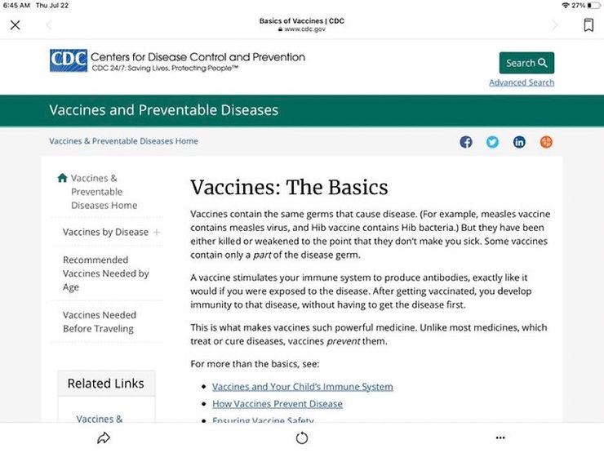
Centers for Disease Control and Prevention (2020)
Following the rollout of the COVID-19 vaccine in 2021, however, the CDC abruptly changed its definition of vaccines. Now a vaccine doesn’t have to create immunity or prevent a disease; it simply needs to “stimulate the body’s immune response.” (It’s worth noting that shortly before the CDC revised its definition experts discovered that the COVID-19 vaccines, while significantly reducing severe illness and death, didn’t create immunity or prevent infection or transmission).

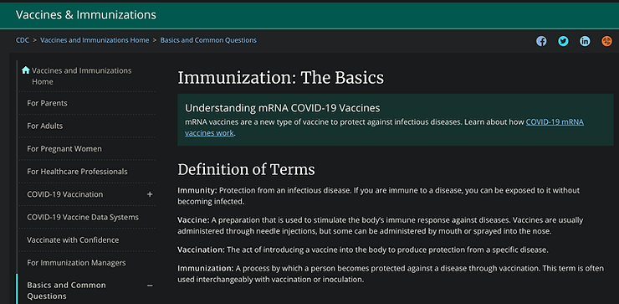
Centers for Disease Control and Prevention (2021)

If you’ve always gotten vaccinated because you believe a vaccine should confer immunity and prevent disease, you might be hesitant to get jabbed with a novel drug that only stimulates an immune response but doesn't keep you from getting infected. But if you were one of the people who clung to this centuries-old definition of a vaccine, you suddenly became an “anti-vaxxer.” You see the problem? When half the country accepts a new definition of a vaccine while the other half clings to one we’ve embraced for generations, division and polarization are inevitable.

This phenomenon is also unfolding in economics. For more than a century, a “recession” has been widely recognized as “two consecutive quarters of decline in gross domestic product (GDP).” But as inflation has torn through the U.S. economy, this definition has changed. Now experts tell us that a decline in GDP, alone, isn’t sufficient to pull an economy into recession; “other factors” need to be taken into account, such as personal income, payrolls, manufacturing and trade sales and industrial production (bear in mind that all these factors contribute to GDP, which is why GDP has been the rule of thumb for determining a recession). But when half the country thinks the economy is doing well enough to escape recession while the other half thinks danger is imminent, they’re living in different realities. Division is guaranteed.

If you take a close look at what’s happening now, you’ll see that our language is rapidly being re-defined in other areas. For thousands of years, humans have had a near-unanimous understanding of the genetic characteristics of a “man” and “woman” — yet these definitions are now in flux. There’s no longer even a consensus on whether women are the only people who can get pregnant.

A “conspiracy theorist” used to be a person who believes that powerful forces secretly collude to engage in illegal or unethical activity, but now the definition has expanded significantly. Today, anyone who questions a popular narrative or floats an unusual idea can find themselves branded with this label. A Facebook friend recently accused me of being a conspiracy theorist because I posted a NASA photo of what appeared to be a doorway on Mars.

A racist used to be someone who discriminates against a person based on the color of their skin; now a racist can be anyone (with power) who treats a person with a different skin color poorly for any reason.

Freedom of speech used to be the right to express any opinion or belief; now it’s merely the right to repeat popular opinions or beliefs that don’t offend or go against the mainstream narrative.

The list goes on.

Our language is being re-defined and twisted, and it’s dividing us at every turn and sending America deeper into polarization. The question we should be asking ourselves is, who benefits from this division?

You probably know my thoughts on this, but it bears repeating: when we’re divided and distracted, we can’t see the Big Picture. We can’t see what’s really causing our systemic failures or how we can come together to fix them. We don’t focus on the fact that the Ponzi scheme we’re trapped in has allowed the top .1% to accumulate as much wealth as the bottom 90%. We don’t focus on the inflation that’s eating us alive or the taxes we’re still expected to pay while we’re being eaten. We don’t think about the fact that our elected “representatives” on both sides of the aisle aren’t doing a damn thing as all this happens.

So the next time you find yourself debating someone about the definition of this or that and feel like you’re living in a different world, understand that the person you’re talking to isn’t necessarily bad or ignorant; they’ve simply been steered into a different reality — by design. Be patient with them. Have compassion. Overcoming the division that’s forced us into separate realities won’t be easy, and it won’t happen overnight. But the first step will be to educate ourselves and others about what’s really happening, and why.

